Homework 1
Blood Pressure Model
For this exercise, you will need four Matlab files:
1- sa.m : This is your main Matlab file.
2- in_sa.m : This file initiates the values for the previous file
3- psa_new.m : This file is a function that updates the moment to moment values for the systemic blood pressure using Euler’s method.
4- QA_{o}_now.m : This file is a function that updates the moment to moment values for the flow out of the ventricle through the aortic valve into the aorta.
These four files are given on Canvas to download. Download the files in the same directory and study them. They are well annotated. The file, sa.m is the main script and in_sa.m initializes all the constants and initial values of variable. QA₀_now.m looks at the time in each cardiac cycle and decides if the cycle is in systole or diastole. If in systole, it calculates the stroke volume for each $∆t$ between start of systole and end of systole. In diastole, when the aortic valve is closed, the stroke volume is zero. The file, psa_new.m, looks at the blood pressure at each moment in the cycle. It takes the blood pressure at the immediately previous $∆t$ and adds to it the increment of pressure that corresponds to the present time.
Exercises:
- Copy and paste these four files into a new directory in Matlab (give the directory a name that makes it easy to find – I used the very ingenious name: “Blood Pressure”.
Run the code.
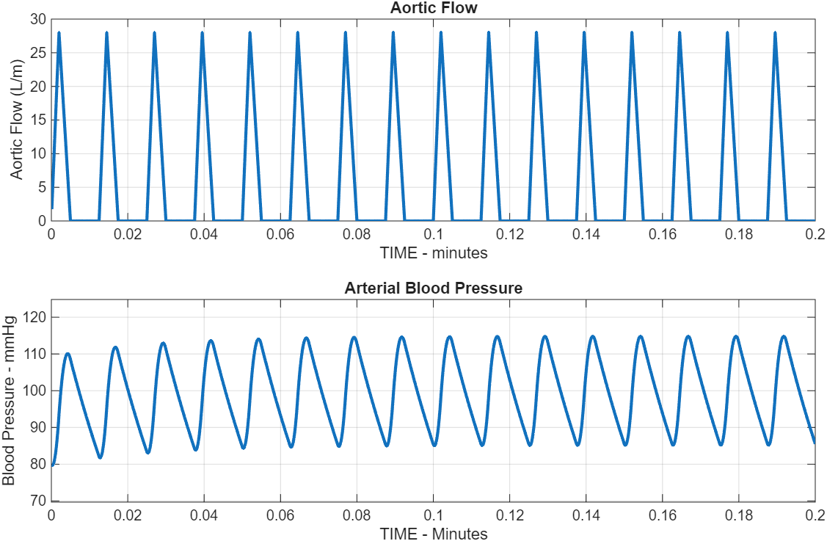
  - Show the resulting plots.

  - Adjust the systemic arterial compliance by trial and error to achieve a blood pressure of about 120/80 mmHg.

    - Did you have to increase or decrease compliance? I had to decrease the compliance to 0.115 liters/mmHg.
    - The adjusted arterial compliance should be considered as the normal value in all subsequent exercises. It might need to be changed again to meet the “experimental” criteria.
    - In all subsequent exercises, be careful to change only the parameter(s) of interest. All other parameters should be reset to the normal values.
  - Note that the pressure starts off at one level and comes into equilibrium after a few beats. Adjust the initial pressure with each exercise so that the pressure curve is in equilibrium ± immediately.

We start the simulation at Psa = 80 mmHg because that’s the normal diastolic pressure and it reflects the system’s natural resting state. It’s the point the cardiovascular system naturally settles at between beats.
By starting at 80 mmHg, the pressure curve stabilizes right away no oscillations, no warm up period. If we picked a different starting pressure, the model would take a few cycles to level out. This approach saves time and gives clean, steady results from the start.
  - Write code to calculate and print the cardiac output (Hint: this can be one simple line of code with a print command or several – both techniques work). Add this code to the main program so that the cardiac output prints out for each of the changes you make subsequently.
%Calculate and print cardiac output
%Cardiac output = average flow over one cardiac cycle
%Use the last few cycles to get steady-state value
cycles_to_use = 4; % Use last 4 cycles
cycle_length = round(T/dt); % Number of time steps per cycle
start_idx = klokmax - cycles_to_use * cycle_length + 1;
cardiac_output = mean(QAo_plot(start_idx:end));
fprintf('Cardiac Output: %.2f L/min\n', cardiac_output);

%Calculate and print systolic and diastolic pressures
%Use the last few cycles to get steady-state values
pressure_data = Psa_plot(start_idx:end);
systolic_pressure = max(pressure_data);
diastolic_pressure = min(pressure_data);
fprintf('Systolic Pressure: %.1f mmHg\n', systolic_pressure);
fprintf('Diastolic Pressure: %.1f mmHg\n', diastolic_pressure);
fprintf('Current Compliance (Csa): %.4f L/mmHg\n', Csa);

- There are two clinical conditions where the systolic pressure is increased, and the diastolic pressure is decreased (widened pulse pressure): arteriosclerosis and aortic insufficiency. We will model aortic insufficiency (also known as aortic incompetence or aortic regurgitation) in homework project 2 when we have a model of the left heart. Arteriosclerosis is a different pathological entity from atherosclerosis. Be careful in your research. When you Google arteriosclerosis, you will find that most articles confound the two pathologies. They are different.
  - Explain, in detail, what each pathology, arteriosclerosis and atherosclerosis, entails and how they differ. This requires a short essay based on histological description.
Arteriosclerosis is basically when the arteries thicken and lose their elasticity. Once they stiffen, blood doesn’t flow as smoothly, and circulation takes a hit. It’s an umbrella term, and atherosclerosis falls under it. The causes varied aging, high blood pressure, diabetes, and even long-term inflammation can push things in this direction. At its core, arteriosclerosis comes down to fibrosis and calcification of the arterial walls.
Atherosclerosis, on the other hand, is the specific form of arteriosclerosis people usually think about. It’s defined by plaque buildup inside the intima of medium and large arteries. The process starts with damage to the endothelium, which opens the door for lipids to seep in, macrophages to show up, and foam cells to form. Over time, you end up with a fibrofatty lesion, essentially a necrotic lipid core surrounded by inflammatory cells, topped off with a fibrous cap made of smooth muscle and collagen. This narrows the lumen and weakens the arterial wall. If the plaque ruptures, it sets off clot formation (thrombosis), which can block arteries and cause serious downstream problems.
    - Use annotated images different from those used in class (drawing your own works).
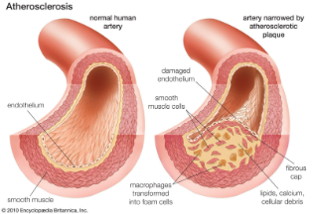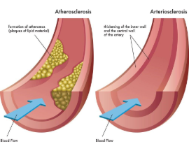
    - Note that both pathologies contribute to the development of hypertension.
    - While arteriosclerosis may reduce arterial diameter somewhat (maybe $≈$5-10%) its major effect is to stiffen the arterial wall significantly. Atherosclerosis introduces significant arterial strictures (stenoses) as well as stiffening the artery
    - What one parameter would you change in the model to best make the model reflect significant wall stiffening from arteriosclerosis? I would change the Csa to 0.008. This single parameter change will effectively model the stiffening of arterial walls that occur in arteriosclerosis, making the arteries less able to expand and contract with each heartbeat, resulting in higher blood pressures and altered hemodynamics.
    - Construct a for/loop in the main Matlab script to change this parameter to make the blood pressures approximately ±140/±65 mmHg and ±180/±50 mmHg. These values are not unusual in older patients with significant arteriosclerosis and account for many cases of idiopathic hypertension in those over 60 years of age.
    - Explain how you changed the MATLAB file (you do not need to show the entire file!), for instance, “I created a for/loop that changes the ___ from its initial value to ___ by increments of ___ …“). I set up a for-loop that steps the compliance (Csa) down from its initial value of 0.0015 L/mmHg to 0.0003 L/mmHg, using increments of about 0.0002–0.0003 L/mmHg. This simulates the arteries, making them progressively stiffer. The loop runs through different csa_values, and I added an initial condition for psa so all the graphs start from the same baseline. That way, the changes you see in the plots come directly from the decreasing compliance and not from different starting points.
    - Show your plots (labeled as is usually expected) with the parameter values used noted in the plot title
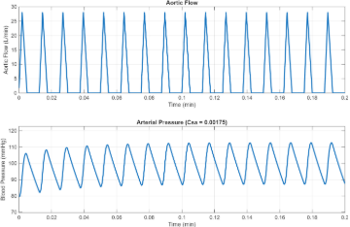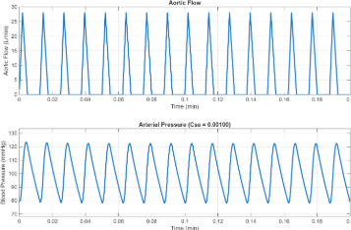
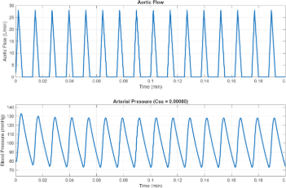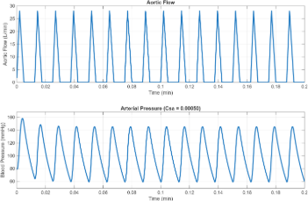
    - Explain why the presence of arteriosclerosis results in increased systolic pressure and decreased diastolic pressure. This will require understanding why a diastolic pressure exists at all. This requires a thoughtful but short essay.
Blood pressure isn’t constant; it swings between systolic (the peak when the ventricles are ejecting blood) and diastolic (the low point during ventricular filling). How big that swing is depends on arterial compliance, which is just the ability of arteries to stretch and snap back as blood volume changes.
In a healthy system, the elastic fibers in arterial walls let the arteries expand during systole to handle the surge of blood from the heart. Then in diastole, those same fibers recoil, which keeps the pressure from dropping off too fast and helps maintain steady blood flow.
When systole hits, the heart pushes blood into the aorta and arterial tree. If the arteries are compliant, they expand and buffer the rise in pressure. But with arteriosclerosis, the stiffened walls don’t stretch as much. The same stroke volume gets forced into a less flexible system, so systolic pressure spikes harder and sharper.
On the flip side, if the arteries can’t recoil properly during diastole, the pressure falls off quicker than it should. That’s why arteriosclerosis not only raises systolic pressure but also drops diastolic pressure — the classic widened pulse pressure.
- Now consider arteriolosclerosis.
  - How is arteriolosclerosis different from arteriosclerosis? That is, which vessels are affected and how are they affected? There are multiple causes of arteriolosclerosis but diabetes mellitus is certainly the most common (about 12% of the American population is diabetic or around 38 million people!). Arteriolosclerosis is also a cause of hypertension.
Arteriosclerosis and arteriolosclerosis are related but not the same thing. Arteriosclerosis refers to disease of large arteries, such as aorta, carotid, or femoral vessels. In these arteries, the walls harden and stiffen because of calcium and lipid deposits. The loss of elasticity reduces compliance, meaning the arteries can’t expand and recoil properly with each heartbeat. Over time, this often includes the formation of atherosclerotic plaques. The big-picture effect is an increase in pulse pressure so systolic pressure goes up while diastolic pressure drops, because stiff arteries can’t buffer the changes. In a systems model, this is represented by reduced compliance (Csa). Common causes include aging, hyperlipidemia, smoking, and hypertension.
Arteriolosclerosis, on the other hand, specifically affects the small resistance vessels, the arterioles, usually 10–100 microns in diameter. The changes here look different: the walls thicken (from hyaline deposition or smooth muscle hypertrophy), the lumen narrows, and the vessel loses its ability to dilate normally. This raises resistance to blood flow, which increases systemic vascular resistance and contributes directly to hypertension. In a model, this process is captured by an increase in systemic resistance (Rs).
  - What one parameter would you alter to best demonstrate the hypertension caused by arteriolosclerosis in our model?
To best demonstrate hypertension caused by arteriolosclerosis in the model, I would alter the systemic resistance (Rs) parameter. Arteriolosclerosis narrows the small resistance vessels (arterioles), which directly increases peripheral resistance. As Rs increases, both systolic and diastolic pressures rise, but the mechanism is rooted in the higher afterload created by the narrowed arterioles. This makes Rs the key parameter to change when modeling arteriolosclerosis-induced hypertension.
  - In the script provided, change that parameter to cause a hypertension of about ± 150/105 mmHg. Show your plot and label it to explain what parameter you changed to what value to generate the plot.
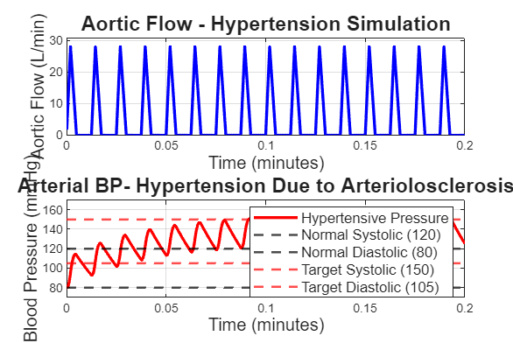
I adjusted the Rs parameter to 22.9, which brought the values close to the target blood pressure of 150/105. To fine-tune the graph and hit the required pressure more accurately, I also lowered the systemic arterial compliance from Part A.
  - How is the hypertension generated by arteriolosclerosis different from that of arteriosclerosis? Arteriolosclerosis affects small arteries and arterioles, increasing systemic resistance due to wall thickening and lumen narrowing. This raises both systolic and diastolic pressure and is often linked to diabetes and kidney disease, with a high risk of end-organ damage.
Arteriosclerosis, on the other hand, involves large and medium arteries. It reduces arterial compliance through stiffening and calcification, which mainly elevates systolic pressure and pulse pressure. It’s more common with aging and can lead to left ventricular hypertrophy
  - What do the previous, in silica, experiments tell you about the inherent properties of the arteries vs. those of the arterioles?
In silico modeling shows key differences between arteries and arterioles. Arteries act like pressure buffers. They’re compliant (stretchable), which helps absorb and release pressure from the heart. When compliance (Csa) drops — like in arteriosclerosis, systolic, and pulse pressure go up, but flow doesn’t change much. They’re like elastic reservoirs that dampen the heartbeat’s pressure spikes. Arterioles, on the other hand, are the main resistance points. Their job is to control where and how blood flows. When systemic resistance (Rs) increases like in arteriolosclerosis, both systolic and diastolic pressure rise, without necessarily changing pulse pressure. These vessels are more about precision blood delivery.

- Amongst the causes of arterial hypertension, consider obesity. Severe obesity (also called morbid obesity, BMI > 35) is an epidemic in this country ($≈$10% of the population and increasing), especially in the south and Midwest. It is a major cause of hypertension even in younger obese individuals of 12-20 years of age. Severely obese individuals need to perfuse the increased body mass. Adipose tissue is living tissue and needs blood perfusion like any other living tissue. Therefore, cardiac output is increased in these individuals.
  - To simulate the circulation in a morbidly obese person:
    - cardiac output is increased. This occurs naturally in the obese to provide oxygen and nutrition to all that extra tissue. To increase cardiac output, we need to increase heart rate and stroke volume. To increase heart rate, you will need to decrease the period, T and the times in systole, T_{max} & T_{S}, by the same proportion (divide each by 1.25) to increase the heart rate to 100/min.
    - In a morbidly obese teenager without diabetes, arterial compliance and arteriolar resistance will be normal. Leave those parameters at the normal values.
    - Cardiac Output is stroke volume x heart rate (now 100/min). Increase the maximal aortic flow (Q_{max} by 40% over the initial value). Stroke volume is
½ T_{S} x Q_{max}. Since T_{s} has been decreased, Q_{max} must be increased.
    - How does this person’s hypertension differ from the hypertension caused by arteriosclerosis?
Hypertension Increases as well as the cardiac output
      - In terms of pulse pressure and diastolic pressure
    - What is the cardiac output in this obese individual
    - What is the cost to the morbidly obese
For the morbidly obese, the heart has to pump much harder to move the increased blood volume, which leads to chronic volume overload. Over time, the heart adapts by undergoing hypertrophy to handle the extra workload. But when this hypertrophy becomes chronic, the heart eventually can’t keep up, and that progression can lead to heart failure. On top of that, the higher oxygen and energy demand strains the myocardium, raising the risk of myocardial infarction.
    - What does the hypertension do to the work the heart performs to maintain adequate cardiac output
Hypertension raises afterload — the resistance the heart has to push against to eject blood into the arteries. In morbid obesity, this burden is doubled: cardiac output goes up because of increased blood volume, and at the same time the heart has to perfuse a much larger mass of adipose tissue. Together, that creates constant strain on the heart.
    - Research how the heart compensates for chronic increased workload. Write short essay that explains this cardiac remodeling.
When the heart is under chronic stress, whether from increased afterload or preload, it adapts to keep cardiac output up and meet the body’s demand.
Hypertrophy develops as cardiac muscle cells enlarge, thickening the ventricular walls. This lets the heart generate more force and maintain stroke volume despite the extra workload. At the same time, the body triggers neurohormonal activation so the sympathetic nervous system and the renin–angiotensin–aldosterone system (RAAS) kick in, raising heart rate, contractility, and blood volume. In the early stages, the heart may even increase capillary density to improve oxygen delivery to the growing muscle.
Over time, though, these changes can become maladaptive. Fibrotic remodeling replaces normal myocardium with stiff, non-contractile scar tissue. That limits both contraction and relaxation. From there, you can see two main dysfunctions: Systolic dysfunction → impaired contraction, reduced ejection fraction, lower cardiac output.
Diastolic dysfunction → impaired relaxation and filling, raising pressures.
Chronic overload can also cause ventricular dilation, where the chambers enlarge, wall tension rises, and contractility drops further thus setting the stage for outright heart failure.
Ultimately, heart failure can develop through reduced cardiac output, neurohormonal imbalance, end-organ damage, or arrhythmias (abnormal heart rhythms).

- Next, consider normal exercise. During exercise, systemic resistance falls because of autoregulation in the working muscles (vasodilation of intramuscular arteries and arterioles). As an example, consider a reduction in systemic resistance by a factor of 2. The response of the body is to ± double the cardiac output (so that the systemic arterial pressure will not fall), and this is achieved primarily by increasing heart rate and stroke volume. In the trained athlete, stroke volume can increase markedly. In the rest of us, less so!
  - Halve the arterial resistance

  - We can increase the heart rate in our model by dividing by the same amount all three of the times: T (the duration of the cardiac cycle), TS (the duration of systole), and TMAX (time from start of systole to maximal aortic flow). To achieve a heart rate of ± 120 beats/min divide all three time parameters by 2.
The above prescription is, of course, simplified. When heart rate changes in exercise, the corresponding changes in the duration of systole are less pronounced than those in the duration of the whole cardiac cycle. In other words, systole which occupies 40% of the cardiac cycle at rest, may occupy 50% of the cardiac cycle during exercise. We ignore this slight modification in this model.

  - We can increase stroke volume by increasing QMAX, the maximum aortic flow in liters/min by doubling QMAX.
  - What is the stroke volume and cardiac output at these new settings?
Stroke volume will be (.5)*((.4)*(0.00625))*(56)=0.07 L/min or 70 mL/min
Cardiac output will be 0.07*120= 8.4L/min

  - What is the blood pressure
Blood Increased compared to the first activity, roughly around 150/60
  - This truly reflects changes induced during exercise
  - Submit the plots that demonstrate this exercise. What is the new stroke volume and cardiac output and how does it compare to resting values
Aortic Flow nearly doubles while blood pressure also increases
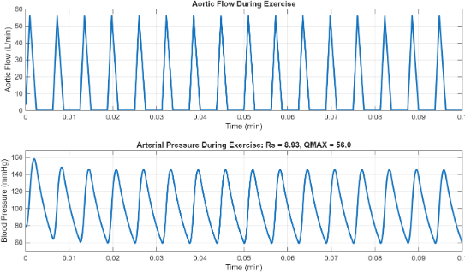
- Finally, it is of interest to see what happens to the arterial pulse when the normal periodic pattern of heartbeats is temporarily interrupted, as it is in in 2nd degree heart, where some atrial contractions are not transmitted to the ventricles and the beats are dropped block or intermittent 3rd degree block where there is no correlation between atrial activity and ventricular activity, i.e. the atria beat regularly but the ventricles are detached from those signals and beat autonomously at a much lower rate.
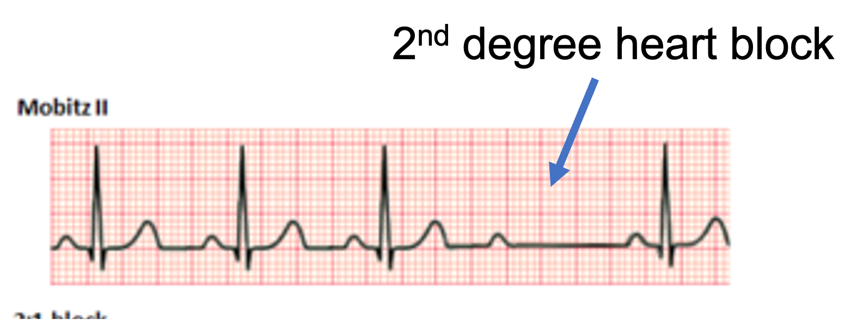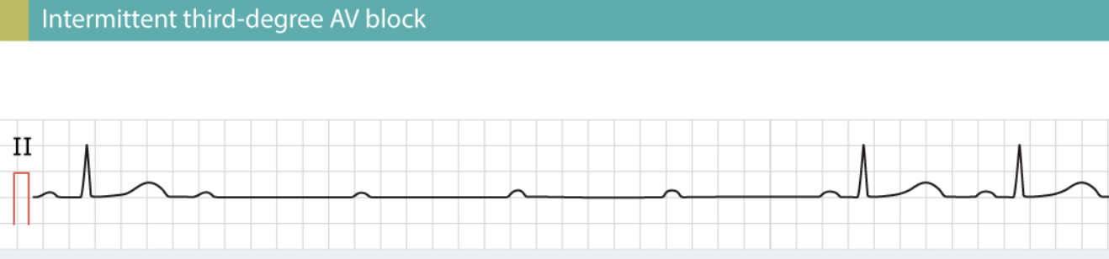
  - The script sa.m runs for 12 sec. (0.2 min). Model the situation of a second-degree block that causes the heart to miss several ventricular beats. Make the cardiac output cease (ventricle does not beat) at 1.8 sec. and resume at 7.8 sec.
  - What happens to the arterial pressure during the arrest period?
Arterial pressure begins at a normal level of about 120 mmHg, but by 0.03 min it drops sharply in an exponential decay. This happens because no blood is entering the arteries. By 0.14 min, the pressure reaches zero, indicating a complete absence of ventricular ejection.
  - How long until the blood pressure is adequate to perfuse the brain?
To maintain consciousness, the brain needs a minimum perfusion pressure of about 50–60 mmHg. Based on the graph, it takes around 0.11 minutes for arterial pressure to restabilize back into that range.
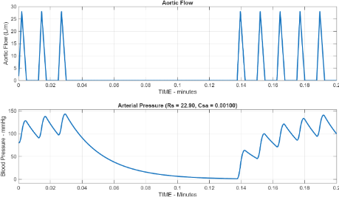
  - To simulate this, we must modify the function QAo_now(t) so that its output is zero between two specified times t_arrest = 0.03 min and t_restart = 0.13 min, and normal otherwise. I’ll leave the programming details to you. Submit your program changes and your plots.
- function Q = QAo_now(t, t_arrest, t_restart)
- %filename: QAo_now.m
- % Function to calculate aortic flow with cardiac arrest capability
- % Inputs:
- % t - current time (minutes)
- % t_arrest - time when cardiac arrest begins (minutes)
- % t_restart - time when cardiac arrest ends (minutes)
- % Output:
- % Q - aortic flow rate (L/min)

- global T TS TMAX QMAX;

- % Check if current time is within the cardiac arrest period
- if t >= t_arrest && t <= t_restart
- Q = 0; % No flow during cardiac arrest
- return;
- end

- % Normal cardiac cycle flow calculation
- tc = rem(t, T); % Time elapsed since beginning of current cycle
- % rem(t,T) is the remainder when t is divided by T

- if tc < TS % SYSTOLE:
- if tc < TMAX % BEFORE TIME OF MAXIMUM FLOW:
- Q = QMAX * tc / TMAX;
- else % AFTER TIME OF PEAK FLOW:
- Q = QMAX * (TS - tc) / (TS - TMAX);
- end
- else % DIASTOLE:
- Q = 0;
- end

- end

  - Note that the recovery of BP to normal blood pressure is longer than the duration of the block. This explains syncope frequently associated with any significant heart block.

Submit your answers in .doc or .docx format. Be sure your graphics have labeled axis and titles and whatever other information is appropriate.

